## ENGR315 – Final Lab Project

**Objectives:**

1. Learn how to use the Arduino Uno microcontroller to read sensors, run motors and collect data.
2. Use Tableau to process data and display it in a “Dashboard”.

You are responsible for designing, building, and using a measurement system. All the data used in this project should be your own. You are to use the provided Arduino kit, temperature sensors and a dc fan. The final report for this project will be due December 12 at 5 PM in the box outside the door of Prof. Groenenboom’s office (SB155) and in Moodle.

### Part A

*Experiment 1. Arduino Kit:*

You will receive an Arduino Starter kit similar to the one in the figure below. Log in the [Records & review file](https://calvincollege-my.sharepoint.com/:x:/g/personal/mlg32_calvin_edu/EXaf9LcKwHBMmyfIUug0il8BTSy06Cz9Oscpqwh6e_i-0A?e=eiVgLu) your name and your partner’s name by your kit number ). Take a screen shot of the File with your Arduino kit record for your report. **If you are missing boxes or parts, you must request them from Prof. Groenenboom the day you receive the kit.**

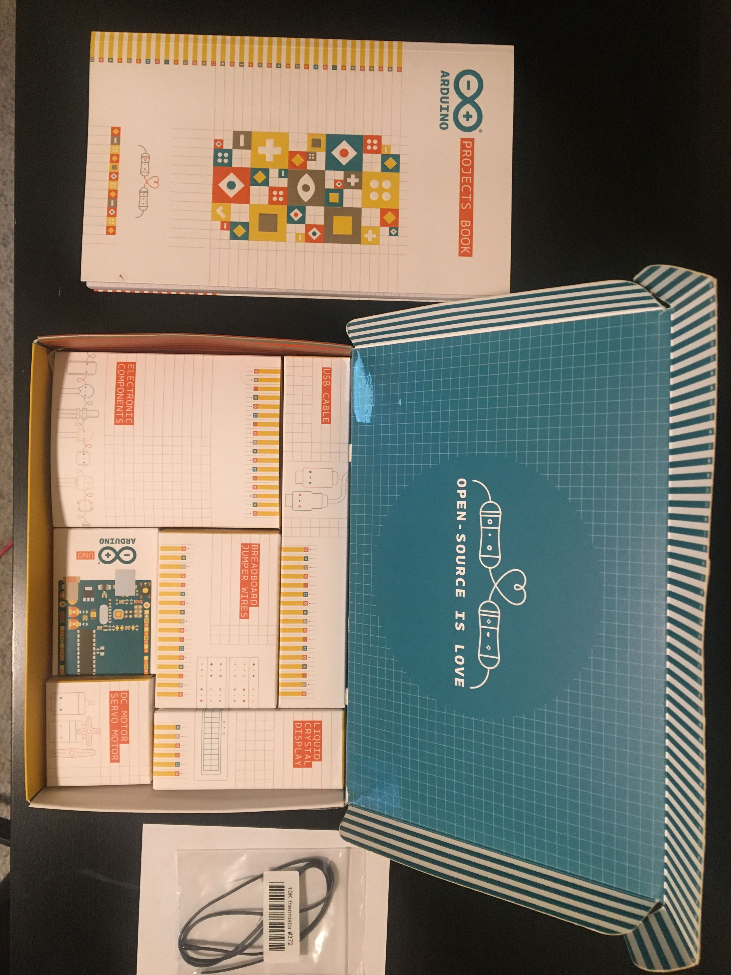

*Figure 1. Arduino kit contents, not including DC fan*

*Experiment 2. Get to know your tools*

* + 1. **Software and basic Hardware:**

Run Experiments 00 and Experiment 01 of your Arduino Kit book. Install the Arduino driver on your computer. Make sure you understand how the Arduino software and the hardware work. Make sure you understand the Arduino pins and how to use the breadboard and LEDs.

* + 1. **Sensors and the Serial Monitor:**

Run Experiment 3 in the Arduino Kit book.

* + - 1. Record test data for the results of the Love-o- meter with 3 of your classmates.
      2. Take a picture of at least one of the LED responses.
      3. Make a table with the data. There should be at least 2 different responses to prove the design works.
      4. Make sure you understand how to read data from a sensor using the *serial monitor*.
    1. **Servo Motor:**

Run Experiment 5 in the Arduino Kit book until page 68 (Just proof of concept).

In a single paragraph, in your own words describe how does a servo motor work and how you used the Arduino to make it move.

* + 1. **DC Motor:**

Run Experiment 10 in the Arduino Kit book until page 110 (Just proof of concept). Replace the dc motor with the dc fan and test the ON/OFF switch and use the potentiometer to change the speed.

In a single paragraph, in your own words describe how does a DC motor work and how you used the Arduino to make it move, explain how does the H bridge work. Comment on the use of the DC fan in the same circuit.

* + 1. **LCD Screen:**

Run Experiment 11 of your Arduino book and record at least 3 questions and take a picture of the crystal ball answer for each question. There should be 3 different answers for this test to prove that the design works properly.

Make sure you understand how to use the LCD screen. **Before you take apart this experiment, read part B, in case you want to use the LCD Display.**

### Part B

*Experiment 1. Plant temperature measurements*

* + 1. Program your Arduino to measure temperature using the [10K Precision Epoxy Thermistor](https://www.adafruit.com/product/372?gclid=EAIaIQobChMI0NvUrY2H9AIVIQV9Ch253gdqEAQYASABEgLb1fD_BwE)s.
    2. In the “room” supplied, place the sensors as follow:
       1. Place the Arduino in the box and one of the 10K Thermistors near the opening for the hot air intake. This sensor will supply the temperature of the hot air entering the box.
       2. The second 10K Thermistor on the opposite side of the box, on the top, approximately 5 cm below the top edge of the box and at least 1 cm away from any side walls. The thermistor should not be more than 5 cm away from any wall. This will be the temperature of “the room”.
    3. Close all the windows in the box and put the lid on and prepare a timer and test running the heater manually in the HIGH setting.
    4. Test turning on and off the heater in the HIGH setting, and keeping it in the right location for the test.
    5. Turn the heater ON in the HIGH setting for 10 seconds and OFF for 50 seconds, run this pattern for 5 cycles. Collect the data of the heater and room behavior. This will be your “Plant” data.
    6. Before you start a test, make sure the “Plant” is back at room temperature.

*Experiment 2. Stabilize the room temperature*

* + 1. Analyze the “Plant” data and determine whether you need to intervene to stabilize the temperature in the room to meet the following specifications:
       1. The first two cycles are considered transient and there are no limits to the temperature during this time.
       2. The last 3 cycles are considered “steady state”.
       3. The room temperature must be with in the deadband in the last 3 cycles. The upper and lower limits of the deadband are 85°F and 95°F respectively.
       4. There should be some effort made to minimize ripple.
    2. Based on your findings, write a problem statement.
    3. Design a setting that will make the room pass the design specifications. Here are the variables you can use:
       1. “Room” windows, open/close. You may not make any more windows/holes on the structure.
       2. The lid of the “room” on/off.
       3. The servo motor to control window(s).
       4. The DC fan for air inflow or outflow or both. Limit this to 2 fans maximum.
       5. Make your own fan with the DC motor provided in the kit.
       6. Any other variable/changes must be approved by your professor.
    4. Given the variety of variables, each time should come up with a different configuration.

**Note:** Sharing test results with another team is considered plagiarism.

* + 1. You cannot modify the heater or the intake area for the heater in any way.
    2. Test your configuration and make sure you document properly the testing done including variables and data so you can report on it. Include pictures of the different set-ups you try.
    3. If you damage parts of the kit, please let Prof. Groenenboom know immediately so the parts can be replaced.
    4. You are expected to keep the EB Mezzanine lab area clean and pack the dyers in the boxes after use, **every time**. You make take your box, heater and kit home for testing.

*Deliverables and due date:*

Demo:

You must be ready to demo your set up the day you signed up for in here [Records & review file](https://calvincollege-my.sharepoint.com/:x:/g/personal/mlg32_calvin_edu/EXaf9LcKwHBMmyfIUug0il8BTSy06Cz9Oscpqwh6e_i-0A?e=eiVgLu). During the demo, the team must show the initial “Plant” temperature measurements chart and must do a demo of the set up meeting the specifications. All demos will be done in the EB mezzanine.

The due date for the project report is December 8, 2021 at 5 PM

Your deliverables should include the following:

1. A memo report for parts A and B.
2. A printed dashboard made with Tableau including:
   1. Title, including student names
   2. 4 charts, with reference lines for deadband:
      1. “Plant” temperature measurements/performance scattered plot
      2. Two of the possible set ups (that was not successful)
      3. Final set up test
   3. Problem description area
      1. Problem statement
      2. Final set up description
      3. Conclusion based on chart data
3. Submit in Moodle and drop off a printed report and dashboard in the box outside the door of Prof. Groenenboom’s office (SB155) Include:
   1. The Arduino code used.
   2. Memo report
   3. A screenshot of your dashboard

Part C

*Kit return:*

All projects must be disassembled, sorted with all items returned in the original boxes and returned to the Engineering Office main table in the front of the office no later than the last day of class. Kits returned after December 8,2021, will incur a penalty of 10% of the overall project grade per day late. Kits not returned with the parts on the appropriate boxes will receive a 10% penalty.

*Teams:*

Section A

|  |  |  |
| --- | --- | --- |
| Team Number | Student 1 | Student 2 |
| 1 | Ben DeWeerd | Jonathan Jansma |
| 2 | [Haocheng Jin](https://moodle.calvin.edu/user/view.php?id=22562&course=54459) | [Meron Kebede](https://moodle.calvin.edu/user/view.php?id=20443&course=54459) |
| 3 | [James Kulaga](https://moodle.calvin.edu/user/view.php?id=18193&course=54459) | [Daniel Luce](https://moodle.calvin.edu/user/view.php?id=20323&course=54459) |
| 4 | [Jack Martinez Sabag](https://moodle.calvin.edu/user/view.php?id=20795&course=54459) | [Hayden White](https://moodle.calvin.edu/user/view.php?id=20535&course=54459) |
| 5 | [Peter Peng](https://moodle.calvin.edu/user/view.php?id=21735&course=54459) | [Belina Sainju](https://moodle.calvin.edu/user/view.php?id=21084&course=54459) |
| 6 | [Emmett Slater](https://moodle.calvin.edu/user/view.php?id=18468&course=54459) | [Isaac Spackman](https://moodle.calvin.edu/user/view.php?id=20715&course=54459) |
| 7 | [Rohan Wadhawa Mall](https://moodle.calvin.edu/user/view.php?id=20994&course=54459) | [Jacob Van Wyngarden](https://moodle.calvin.edu/user/view.php?id=21954&course=54459) |
| 8 | [Matthew Vander Schaaf](https://moodle.calvin.edu/user/view.php?id=20854&course=54459) | [Kristopher Miedema](https://moodle.calvin.edu/user/view.php?id=20775&course=54459) |
| 9 | [Jonathan Washburn](https://moodle.calvin.edu/user/view.php?id=22262&course=54459) | [Kelsey Yen](https://moodle.calvin.edu/user/view.php?id=20985&course=54459) |
| 10 | [Samuel Ydenberg](https://moodle.calvin.edu/user/view.php?id=20278&course=54459) | [Samuel Stonehouse](https://moodle.calvin.edu/user/view.php?id=20222&course=54459) |

Section B

|  |  |  |
| --- | --- | --- |
| Team Number | Student 1 | Student 2 |
| 11 | [Drew Stoneburner](https://moodle.calvin.edu/user/view.php?id=23007&course=54456) | [Samuel Essibu](https://moodle.calvin.edu/user/view.php?id=18851&course=54456) |
| 12 | [Jojo Essuman](https://moodle.calvin.edu/user/view.php?id=20911&course=54456) | [Lane Frey](https://moodle.calvin.edu/user/view.php?id=20639&course=54456) |
| 13 | [Anna Giboney](https://moodle.calvin.edu/user/view.php?id=21711&course=54456) | [Nathan Holwerda](https://moodle.calvin.edu/user/view.php?id=20620&course=54456) |
| 14 | [John Stehouwer](https://moodle.calvin.edu/user/view.php?id=18403&course=54456) | [Alex Brannen](https://moodle.calvin.edu/user/view.php?id=20514&course=54456) |